|  |  |
| --- | --- |
| **Assessment task – Narrogin Senior High School** | |
| Year level | 10 |
| Learning area | Technologies |
| Subject | Digital Citizenship |
| Title of task | Website Design Task |
|  | |
| Description of task | Students will design and develop a simple website on a topic of your choice using Canva. The website should showcase information, images, and other media related to their chosen topic. |
| Type of assessment | Inquiry & Analysis, Production & Processing |
| Assessment Weighting |  |
| **Content description** | |
| Content from the Western Australian Curriculum | **Representation of data**  Binary is used to represent data in digital systems  **Collecting, managing and analysing data**  Evaluate and visualise data, using a range of software, to create information, and use structured data to model objects or events  **Digital implementation**  Design plans, using a sequence of steps, and represent them diagrammatically and in English, to solve a problem and to predict output for a given input to identify errors  **Producing and implementing**  Safely apply appropriate techniques to make solutions, using a range of components and equipment |
|  | |
| Assessment conditions | 4 lessons in class |
| Resources | Computers |

**Check List**

* **Part A: Website Design**
* **Part B: Website Publication**
* **Part C: Reflection**

|  |  |
| --- | --- |
| **Marking key** | |
|  | Marks |
| **Part A: Website Design** | Marks |
| Brainstorm |  |
| Brainstorm is completed in detail and includes all key elements (eg. Title, CFA etc.) | 4-5 |
| Brainstorm is completed in limited detail, includes most key elements (eg. Title, CFA) | 2-3 |
| Brainstorm is partially completed, some key elements are missing. | 0-1 |
| Site Map |  |
| Site map is completed in detail and includes all internal and external links. | 4-5 |
| Site map is completed in limited detail and includes some of the links. | 2-3 |
| Site map is partially completed, some external and internal links are missing. | 0-1 |
| **Subtotal** | **/10** |
| **Website Design Part B Site Map** | Marks |
| |  |  |  |  |  | | --- | --- | --- | --- | --- | |  | 8-10 | 6-7 | 4-5 | 1-3 | | Design & Content | Highly creative and consistent design. Content is well-organized, relevant, and engaging | Creative and consistent design. Content is organized and relevant. | Basic design. Content is mostly organized and relevant. | Inconsistent design. Content is poorly organized or irrelevant | | Key Website Elements | Effective header and navigation. Clear and prominent CTA. Well-structured footer. Includes all required internal and external links | Good header and navigation. CTAs are noticeable. Footer is well-structured. Includes most required links | Basic header and navigation. CTAs are present. Basic footer. Includes some required links. | Poor header and navigation. CTAs are missing or unclear. Footer is incomplete. Few or no required links | | Development | Excellent use of Canva's tools. Fully functional website with no errors. | Good use of Canva's tools. Functional website with minor errors | Basic use of Canva's tools. Website functions but with some errors | Poor use of Canva's tools. Website has significant errors or is non-functional | | Usability | Highly user-friendly. Effective use of responsive design | Mostly user-friendly. Good use of responsive design | Basic usability. Some responsiveness issues | Poor usability. Significant responsiveness issues | | |
| **Subtotal** | /40 |
| **Part C - Reflection** | Marks |
| Insightful and thorough reflection on learning and challenges | /8-10 |
| Good reflection on learning and challenges | /6-7 |
| Basic reflection on learning and challenges | /4-5 |
| Incomplete or unclear reflection | /1-3 |
| Subtotal | **/10** |
| Total | **/60** |

**Task**

You are designing a website. Your website needs to include a theme and be visually engaging. Your website also needs links: At least 3 internal links (links to other pages within your website) and 2 external links (links to external websites related to your topic).

Select a topic that interests you. This could be a hobby, a favourite book or movie, a sports team, a travel destination, or any other subject you are passionate about.

Chosen Topic: ___________________________________________________________

**What needs to be Completed:**

**Part A: Design Brief**

*Planning and Research*

• Identify the key sections that should be included in your website (e.g., Home, About, Gallery, Contact).

• Create a simple sitemap to outline the structure of your website. This is where you outline the links in your website (use buttons). You need 3 external and 3 internal links.

*Design and Content Creation*

• Develop a consistent design theme for your website.

• Create a logo (if applicable) and choose a color scheme and typography that represents your topic.

• Write and organize content for each section of the website. This may include text, images, and videos.

*Key Elements of Website Design:*

• Header: Include a clear title and navigation menu.

• Call to Action (CTA): Design prominent CTAs to guide visitors (e.g., "Learn More," "Contact Us," "Sign Up").

• Footer: Include contact information and links to social media or other relevant sites.

**Design Brainstorm – Graphic Organiser**

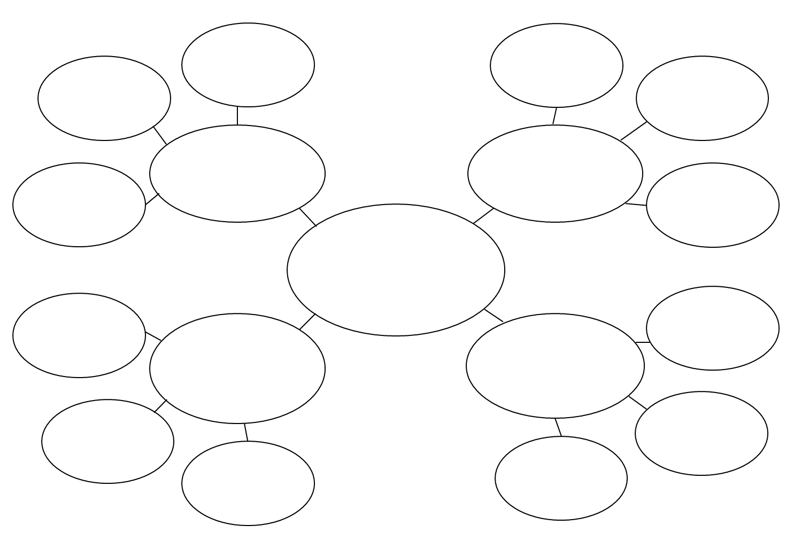

Planning and Research

Design

Key Elements

Content

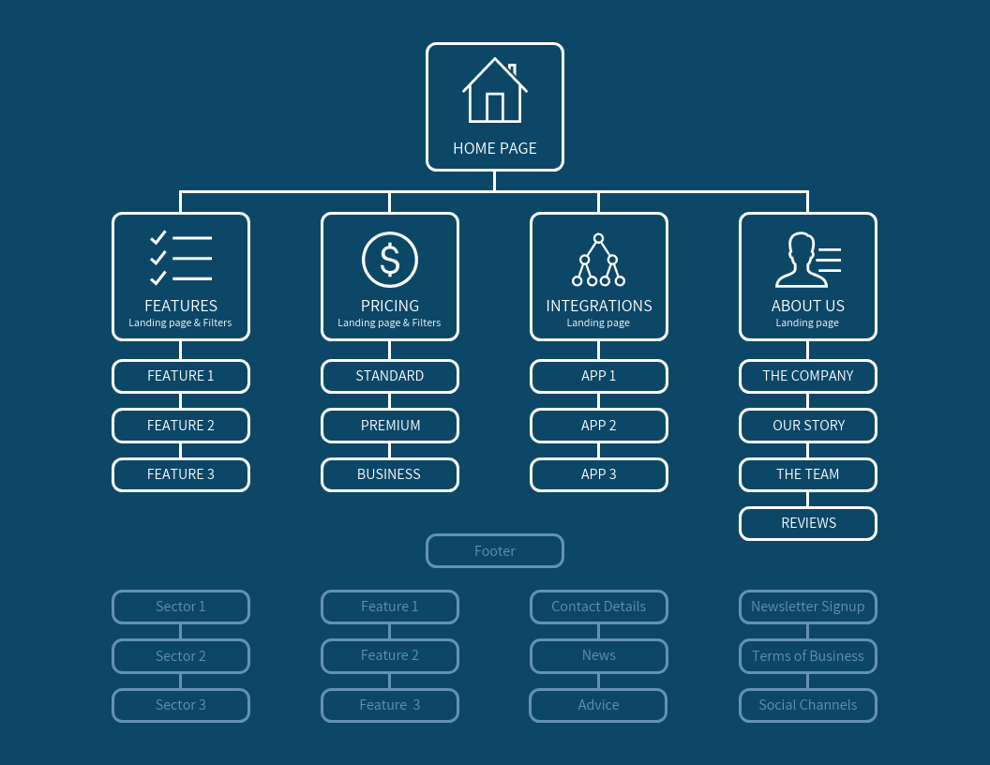**Design Site Map (Concept Map)**

A site map shows the main headings and sub headings for your website. An example is included below. You are required to create one for your website.

Button 5:

External Link

Button 4:

External Link

Button 3:

External Link

Home Page

Button2:

Internal Page

Button1:

Internal Page

**Part B: Website Design**

Create your website on ‘Canva’. You can create your own from scratch or use their templates. Remember to log in using your department email.

Use the below YouTube link (Canva Tutorial) to assist you with any questions you may have during your design.

<https://www.youtube.com/watch?v=tmeOOL58KLM>

After you have finished your Website design you are to publish it. Please make it a private website.

You are to write your URL link to your website below and also copy it to a word document and submit it to your teacher via connect or email.

URL: __________________________________________________________________________________

**Part C: Reflection**

Write a brief reflection on the process of designing and developing the website. Discuss what you learned, any challenges you faced, and how you overcame them. You are to submit a typed copy as part of your final assignment

_______________________________________________________________________________________________________________________________________________________________________________________________________________________________________________________________________________________________________________________________________________________________________________________________________________________________________________________________________________________________________________________________________________________________________________________________________________________________________________________________________________________________________________________________________________________________________________________________________________________________________________________________________________________________________________________________________________________________________________________________________________________________________________________________________________________________________________________________________________________________________________________________________________________________